Current Designation : Senior Lecturer
Date of Birth : 20.02.1982
Nationality : Kenyan
Marital Status : Married
Gender : Female
Profession : Teaching, Consultancy & Research
Specializations : Finance and Marketing
Research interest areas:

- Financial Institutions
- Global Marketing Management
- Financial Services
- Financial Markets
- E-commerce
- E-marketing

CAREER OBJECTIVE:
To work professionally in a dynamic organization with a high degree of dedication and involvement in the direction of achieving the aims and goals of the organization and enhance my professional skills, which allows scope for upward movement.

Special Skills: Proficiency in Microsoft Office, SPSS, and Internet
EDUCATION BACKGROUND:
2007-2010 : Doctor of Philosophy, Faculty of Commerce (Finance)
Mohanlal Sukhadia University, India.
Thesis: Performance Appraisal of Selected Mutual Funds in India
2005-2007 : Masters of Business Administration, (M.B.A)
Bharathiar University, India.

2002-2005 : Bachelor of Commerce (B.Com) Karnataka University, India.
2000-2001 : Maharashtra State Board of Secondary and Higher Secondary Education,
Pune, India.

CERTIFICATION:
Aug 2008 – Jan 2009 : Post Graduate Diploma in Computer Application (PGDCA),
Artech Computer Education, Komarapalayam, Erode, India.
July 2003 : German certificate, Karnataka University, India.

ACADEMIC QUALIFICATIONS:
May 2010, Doctor of Philosophy (PhD) in the faculty of commerce (finance)
Topic of Thesis: “Performance Appraisal of Selected Mutual Fund in India”
(With emphasis on Adoption, Growth trends, Performance of mutual fund with other financial sector, Perspectives and Policy Implication)

April - 2007, Master of Business Administration (M.B.A) 1st Division
Units Covered:
- Financial Management | - Export Management | - Quantitative Methods for Management
- Financial and management accounting | - Strategic Management in India & Global context | - Service Marketing
- Operation management | - Quantitative Techniques, | - Strategic Cost Management
- Financial service | - Managerial Economics | - International Business
- Research Methods for management | - Principles of Insurance Management | - Organizational Behaviour
- Promotion management | - Brand Management | - Management Principles & Practice
- Marketing Management | - Human Resources Management | - Executive Communication
- Computer application in management | - Management Information System | - Equity research & portfolio Management
April - 2005, Bachelor of Commerce (B.Com) 2rd upper Division
Units Covered:
- Financial Accounting | Modern Marketing | - Industrial Economics
- Financial Management | - Computer Application Business | - Cost Accounting
- Managerial Economic | - Banking Law & Practice | - Income Taxation
- Functional Management | - Business Laws

July 2003, Certificate of German, Karnataka University, Dharwad, India
Feb-2002, Higher Secondary Certificate, Maharashtra State Board of Secondary and Higher Secondary Education, Pune, Kolhapur Division board, India (+2) 57%
Subjects:

- English,
- German,
- Economic,
- Book – Keeping & Accountancy,
- Organization of Commerce
- Secretarial Practice

EXPERIENCE RECORD:
Position Held |  | Employer and Courses taught
Senior Lecturer  (Sep 2018 – Feb 2020)  Senior Lecturer  (Oct2015-Aug 2018)  Lecturer  (2012- 2015)  Part – Lecturer  (2012 -2015)  Lecturer  (2010- 2012) |  | Mt Kenya University, Meru campus  Units handled:  - Financial market and institutions - International business finance  - Investment and portfolio management - Introduction to macroeconomic  - Principal of banking and finance - Financial accounting II  Mt Kenya University, Kakamega campus  Units handled:  - Financial management - Managerial accounting  - International marketing - Investment banking and brokerage  - Entrepreneurship - Strategic management  - Research methodology - Financial Accounting  - Financial Reporting  Mt Meru university, Arusha, Tanzania  Units handled:  - Operation and strategic management(MBA) - Project Management(MBA)  - International Business Management (MBA) - Marketing Management (MBA)  - Product and Brand Management(MBA) - - Micro Enterprise(MACD)  The university of Arusha, Arusha, Tanzania  Units handled for MBA Classes:  - Global Entrepreneurship and Marketing - Marketing Communication  - Financial Managerial Accounting - Auditing and Assurance  - Supply and Material Management - Marketing Strategies  Kampala International University, Dar es Salaam Campus, (Tanzania)  Units handled for PHD Classes:  - Financial Management - Theories of Management  - Theories of Management  Units handled for MBA/Masters in Project Planning Management (MPPM) Classes:  - Principles of Project Management(MPPM) - Financial Management  - Project Quality Management (MPPM) - Marketing Management  - Negotiation for project manager (MPPM) - Investment Decision  - Theories of Management - Operation Management  - Financial Analysis & Banking - International Business  Units handled for UG (BBA/BHR) Classes:  - Principles of Management - Supply Material and Management  - Principle of Insurance - Investment Banking  - Portfolio Analysis - Negotiation Skill

ACADAMIC ACHIAVEMENT AND PROFESSIONAL MEMBERSHIP
- Life member, Christian and Scientific Association of Kenya, (CSAK)
- Member, the heights, an international multidisplinary journal, Kampala International University, 2011
- Member, board of PG studies, Kampala International University, Dar es salaam constituent college.
- Editorial advisor, Smart Sage International Research Journal of Business and Management.

OTHER DUTIES AND RESPONSIBILITIES
- Coordinator school of business in charge of under graduate programme, Mt Kenya university Meru 2019 to date
- Coordinator school of postgraduate Mt Kenya university Kakamega. 2016 T0 2018.
- Programme leader of arts in economics and statistics, Mt Kenya University July 2016 to date.
- Chairlady, curriculum review committee, Kampala International University, 2011.
- Member, the heights, an international multidisplinary journal, Kampala International University, 2011
- Developed course curriculum for taught PhD, MBA and MPPM students of Kampala International University, 2011
- Member, Board of PG studies, Kampala International University, 2011
- Business and management studies advisor, Kampala International University, 2011
- Member, SPGSR finance and administration committee, Kampala International University, 2011
- Member, SPGSR research committee, Kampala International University, 2011
- Member, SPGSR administration committee, Kampala International University, 2011
- Editorial board member, the faculty mirror Kampala International University, 2011
- Facilitator, IODL business and management courses, Kampala International University, 2011
- Marketer V.S.R textiles, Erode, Tamilnadu, India Computer Operator (Net Marketing) 2005-2007
- Communicator, Caliber Infocare pvt (B.P.O) Udaipur Rajastan india, 2009-2010

Research Work & Publications
STUDENT’S SUPERVISED

- Wairimu George Gichomo, MBA/2018/21171, “Impact of interest rate on capping on performance of equity bank”, Mt Kenya university,
- Ahmed Abdillahi Ismail, MBA/46871/2016,” Determinants of micro and small enterprises access to finance. Case of Hargeisa Somaliland”, Mt Kenya university,
- Franco Mutua Karuti, MBA/2014/70272, “ Influence of the application of IPSAS Accrual Framework on accountants performance in public sector in kenya a case of Meru county”, Mt Kenya university,
- Mbae Polly Kagendo, MBA/2018/31076, Impact of interest rate changes on bank profitability, a case of KCB Mt Kenya university,
- Pasiliza Muhonja Butoyi , MBA/31644/2015,”Assessment Of Strategic Plan Functional Strategies Influence On Financial Performance Of Private Secondary Schools In Kakamega County, Kenya.” Mt Kenya university,
- Nasoro Rashid MBA/2016/58296, “ The Impact Of Financial Literacy On Small And Micro Enterprises: The Case Of Kakamega Central Sub County” Mt Kenya university,
- John Omollo Omondi MBA/40772/2016, “An Assessment On The Impact Of Organizational Structure On Staff Performance At Kenya Revenue Authority- Kisumu, Kenya Mt Kenya university,
- Wato Halalehe Dabasso, MBA/76382/2014, Assessment of strategic management tools on performance of service industry in Kenya (case of heritage hotel Nakuru Mt Kenya university,
- Antony Mwenda Murungi, MPAM/2018/30376 An Assessment of devolved governments at the local level in Kenya case of Meru county Mt Kenya university,
- Ondere Justus shiyuka, KAK/B/MBA/312/01661,” Assessment of differential the performance of the sugar industry in western Kenya”, Mt Kenya university,
- Bukachi Kenneth kochwa, MBA/2014/67081,” Assesment of logistic management information system (LMIS) implementation and performance of Kenya medical applies authority (KEMSA) services in vihiga county”, mt Kenya university,
- Marcus L. shibele MBA/2014/75675,” An Assessment of the influence of credit risk management practice on loan performance of micro finance intuitions in kakamega county”, mt Kenya university,
- Violet kagasi, MBA/2014/73654, “Influence of Hudumu centers innnovation strategies on government service performance in Kenya a case of Kakamega county”, Mt Kenya University,
- Dominic Kipkosge Rotich, MBA/ 2014/79272, “assessment of Michael’s Porters competitive strategies influence of financial performance of small holder tea factories in Kiambu and Maranga counties, Mt Kenya university,
- Ekwenye Eddysam Emukule MBA/2014/78785, “ impact of micro finance on growth of SME’s in Teso sub-county”, Mt Kenya university,
- Llyas Mohamed Mohamud, MBA/55592/2016, “the impact of mobile bank on financial accessibility. A case study of EVC+, Mogadishu”, Mt Kenya University
- Mastaf Abdi Kilwe, MBA/55774/2016 “The effect of internal systems on the performance of organization in Somalia. A case study of Towfiq Teaden, Bosaso”, Mt Kenya University
- Peter Lobwota Okwara, MBA/48828/2016, “evaluation of tax evasion and its outcomes on fiscal budget of South Sudan: A case study of fiancé directorate of taxation”, Mt Kenya University
- Wycliffe Shiholo, MBA/31723/2015, “assessment of business generic strategies influence on performance of selected sugar factories in western counties. Mt Kenya University”, June 2017
- Bubiru Isack Khalisha MBA/2015/32007,”analysis of capital structure influence on financial performance of saving and credit co-operative societies in Kenya. A case of Muranga, Mt Kenya university”, June 2017
- Edes Joachim Mushi,”assessment of customer satisfaction in Tanzania standard newspapers limited: A case study of Tanzania standard newspapers LTD, Mt Meru university”, October 2014
- John Faustine, “the contribution of print media to poverty reduction: A case study of Ilemela district Mwanza rewgion”, Mt Meru university, October 2014
- Regina Segega, “shallenges hindering women leaders’ advancement at high position in Non-Governmental organization NGO: A case study of world vision. Arucha, Mt Meru university”, October 2014
- Dues Masili Muhoja, “the challenges facing small scale fishermen in Tanzania, a case of Mkinga district”, Mt Meru university, October, 2013
- Clement John Lissawa, “factors affecting clients in loan repayment to microfiance of PRID, Arusha, Tanzania”, The University of Arusha, November 2014
- Benedict Joseph Wella, “The impact of marketing communication on increase of service awareness at national social security fund, Arusha, Tanzania. The University of Arusha”, November, 2014
- Upendo Lobaya, “socio-economic contribution of Non-Govermental organization NGO to Maasai women”, October, 2014
- Mussa Omar Khamis, MPP/0002/102/DT, “Marine costal environmental management programme and the socio-economic growth of local communities in Minir bay, Zanzibar”, 2012
- John John, MBA/008/93/DT, “The impact of rural electrification on tourist marketing in Zanzibar Island”, 2012
- Hamed Hassan Chande, MPP/0004/102/DT, Parent’s socio-economic status and child labour practices in Micheweni district Zanzibar, 2012
- David J. Dadi, “sustainability of communication for malaria intervention: case study of community change agents in Lindi and Tandahimba district councils Tanzania”, September, 2011

(B) PUBLISHED WORK
- Oirere K. Dorcas, et al. (2020), Examining the impact of debt capital on financial performance of saccos in kenya, ISSN 0749030,vol-68-issue-30-February-2020
- Oirere K. Dorcas, et al. (2016), Influence of Huduma Centre Innovation Strategies on government service performance in Kenya; a case of Kakamega county , vol. 2 no. 11 (2016): IJRDO - journal of business management
- Oirere K. Dorcas, et al. (2016), Assessment of michael porter's competitive strategies influence on financial performance of smallholder tea factories: a case of Kiambu and Murang'a counties, vol. 2 no. 11 (2016):IJRDO - journal of business management
- Oirere K. Dorcas, et al. (2015), An Evaluation of the application of E-Commerce Model by Microfinance institutes in Kenya, journal for studies in Management and planning, e-ISSn-23950463, Nairobi, Kenya.
- Oirere K. Dorcas, et al. (2015), An evaluation of E-Commerce in the financial performance of Ketepa, journal for studies in Management and planning, E-ISSn-23950463, Nairobi, Kenya.
- Oirere K. Dorcas, et al. (2010), Role of Agriculture in the Indian economy: its problems &challenges, M.LTribe Research and Training Journal,vol.42,101to 105, Ashok Nagar, Udaipur, India
- Oirere K. Dorcas, et al. (2010), Indicators of Quality leadership, International RCR Management Journal, Vol 18, p.g 189 to 197,India
- Oirere K. Dorcas, et al. (2010 Health Care delivery in rural Rajasthan, M.LTribe Research and Training Journal,vol.42, p.g 121 to125,Ashok Nagar, Udaipur, India
- Oirere K. Dorcas, et al. (2010), Causes of farmers suicides in India and ways to abet them, M.LTribe Research and Training Journal,vol.44, Ashok Nagar, Udaipur, India
- Oirere K. Dorcas, et al. (2010), Global Warming and its impacts in the world economy, Pacific Business Review Journal, vol 36, Udaipur, India.

PRESENTATIONS IN INTERNATIONAL CONFERENCES AND SEMINAR
18th & 19th Feb 2012 World Organization of Students and Youth (WOSY), Shimla, India
Seminar on 6th International Seminar on Role of Youth in Social Transformation
Topic on moral values and ethics (Modeling disciplined character)
26th & 27th Oct 2009: Rajasthan council of educational administration and management And Rajasthan college of agriculture, ACEAM, UCEAM,BCEAM, GCEAM, MCEAM AND Smt. K.B DAVE College of Education, Pilvai.
Seminar on: International Conference on Leadership for Global Excellence
Topic: Indicators of quality leadership
4th Oct 2009: Mohanlal Sukhadia University, Department of Accountancy and
Statistics and Master of Finance and Control Programme, Udaipur
Seminar on: Emerging issues in accounting and finance
Topic on Factors Hindering ICT Implementation in the finance industries

4th Oct 2009: Mohanlal Sukhadia University, Department of Accountancy and
Statistics and Master of Finance and Control Programme, Udaipur
Seminar on: Emerging issues in accounting and finance
Topic on Non-Performing Assets in Public Sector Banks: An Emerging Bottleneck in Kenya
301h Sep 2007: Janardan Rai Nagar Rajasthan Vidyapeeth, department of Accounting, University, Udaipur
Seminar on: Accounting issues
Topic: Transfer pricing

PARTICIPATION WORKSHOPS

8th Dec 2011 Kampala International University Dar Es Salaam constituent college
Workshop on Writing of academic papers
Topic on Implications for policy and practice
3rd &5th Oct 2011 Kampala International University Dar es Salaam Constituent college
Workshop on Pedagogy in higher education
18th april 2011 Kampala International University Dar es Salaam Constituent College, by School of Post Graduate Studies and Research (SPGSR)
Research Workshop Thesis and dissertation supervision
18th april 2011 Kampala International University Dar es Salaam Constituent College, by School of Post Graduate Studies and Research (SPGSR)
Viva voce PhD & Masters theses, internal examiner and panelist

REFERENCES

Dr. Edward Kuasakuala,
Coordinator school of Education
Mt Kenya University, Box 51 Buiere
Email Address: khasakuala@yahoo.com
Mobile No: 0722908890

      - Dr. Lazarus Momanyi Okioma
Senior Lecturer & HOD, Department of Science Education
Moi University, Eldoret
Mobile: 0722211017
Email Address: momanyi1o@yahoo.com
      - Prof S. L. Menaria
Dean and Exam controller Pacific University
P.O Box-12 Pratap Nagar Extn.
Pacific Hills, Airport Road, Udaipur.
Mobile: 0091-9352521993
Email: slmenariadr@yahoo.com

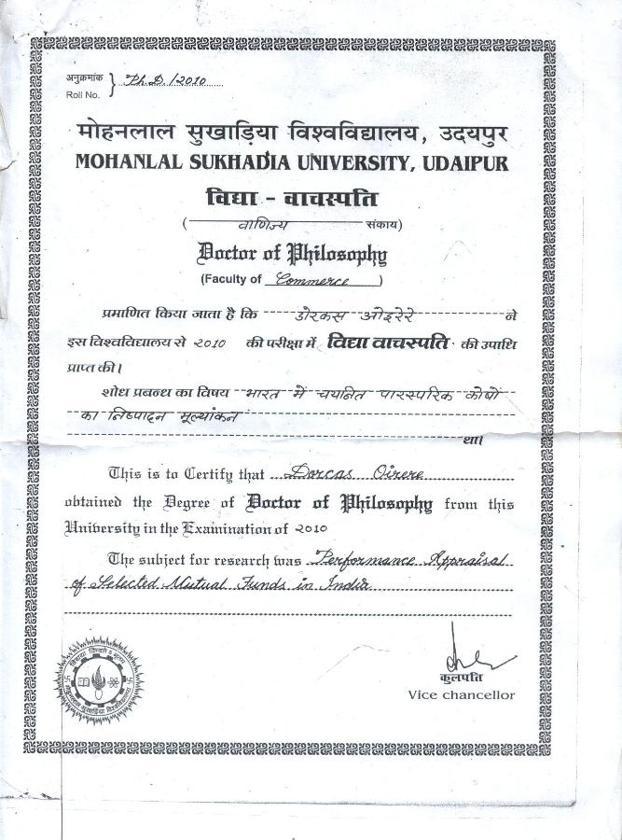

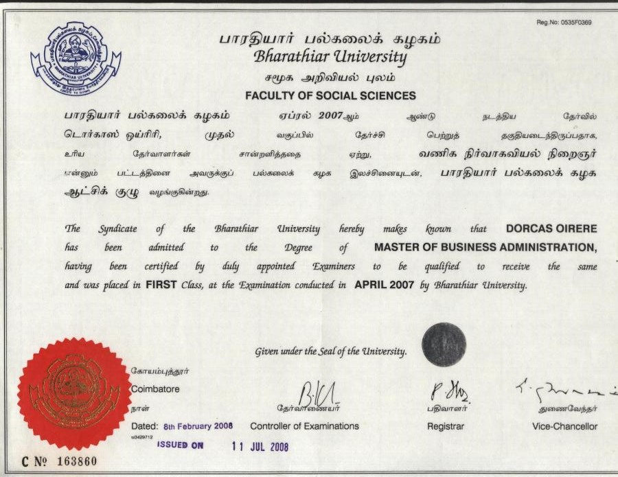

s

